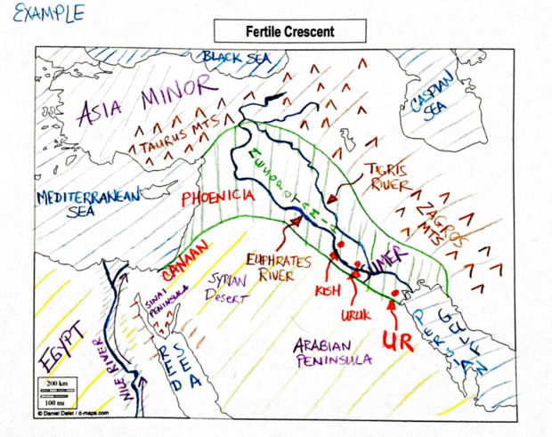
Here is a list of the places you need to learn for a future map quiz:
Land areas: Mesopotamia, Syrian Desert, Sinai Peninsula, Egypt, Asia Minor, Arabian Peninsula.
Mountains: Zagros Mountains, Taurus Mountains
Water areas: Black Sea, Caspian Sea, Mediterranean Sea, Nile River, Tigris River, Euphrates River
Cities: Kish, Babylon, Uruk, Ur, Phoenicia
Other areas: Area of Ancient Sumer, Area of the Fertile Crescent

