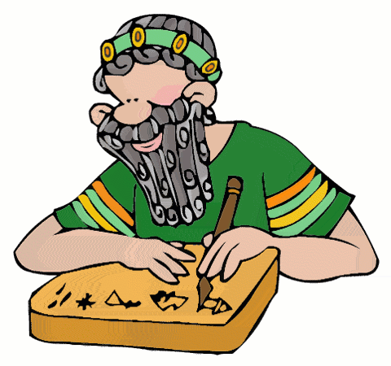
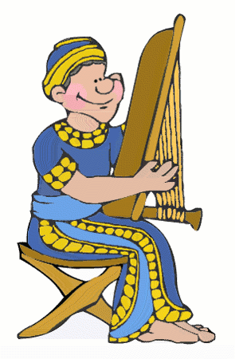
Mesopotamian Menu

Plan a well-balanced meal with a selection from each course (must total 100).

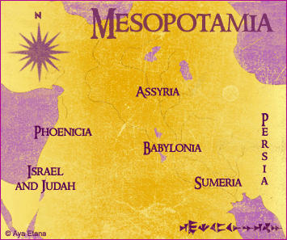
Appetizer: Visual Representation (20 points)
Graph (Pie, Bar or Line)
Infographic (Paper or Computer)
Map (Boundaries of all 4 Empires with major features)
Venn Diagram (Comparing 2 Empires)
Timeline (Choose 5 events representing 1 Empire)

Entrée: Written Representation (30 points)
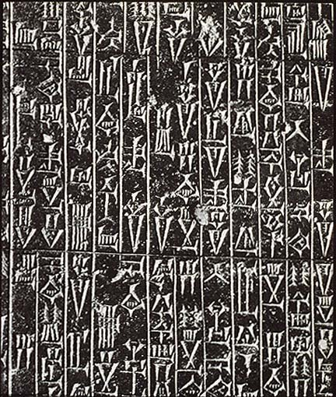
Postcard (Cultural reflections of a tourist writing home)
Text Message (Eyewitness account of a major event in your civilization)
Diary Entry (Reflecting point of view of a member of a specific class)
Comic Strip (Important event, person or innovation)
Menu (foods of the region and time period)
Want Ad (Member of upper class seeks laborer…specific qualities/job)
Trading Cards (4: one person from each empire)
Write a Resume for a leader of an empire in Mesopotamia

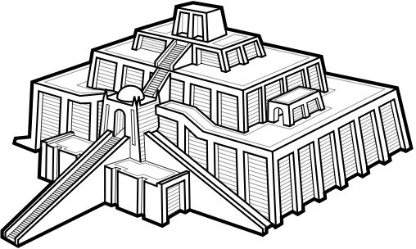
Dessert: Presentation (50 points)
Scrapbook of Civilization (8 essentials, one empire)
Music Video or Live Performance of Original Song
Game of Daily Life (Board or Computer)
Podcast
Interview (Live or Taped)
Travel Agent: Slideshow or Video promoting region

DUE:_____________________________________________________________________________
Signature of Student________________________________, Teacher_________________________
Parent____________________________________________________________________________

